**Results:**

=== **Logistic Regression Results** ===

precision recall f1-score support

0 0.9994 0.9998 0.9996 56864

1 0.8289 0.6429 0.7241 98

accuracy 0.9992 56962

macro avg 0.9142 0.8213 0.8619 56962

weighted avg 0.9991 0.9992 0.9991 56962

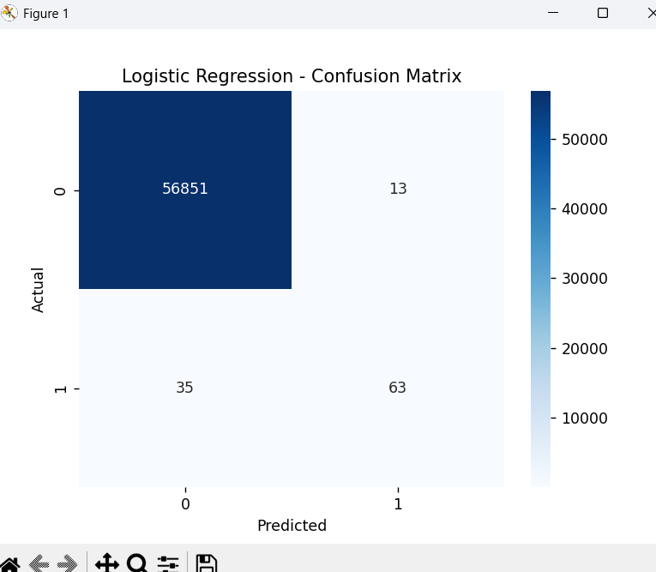

=== **Random Forest Results** ===

precision recall f1-score support

0 0.9997 0.9999 0.9998 56864

1 0.9412 0.8163 0.8743 98

accuracy 0.9996 56962

macro avg 0.9704 0.9081 0.9371 56962

weighted avg 0.9996 0.9996 0.9996 56962

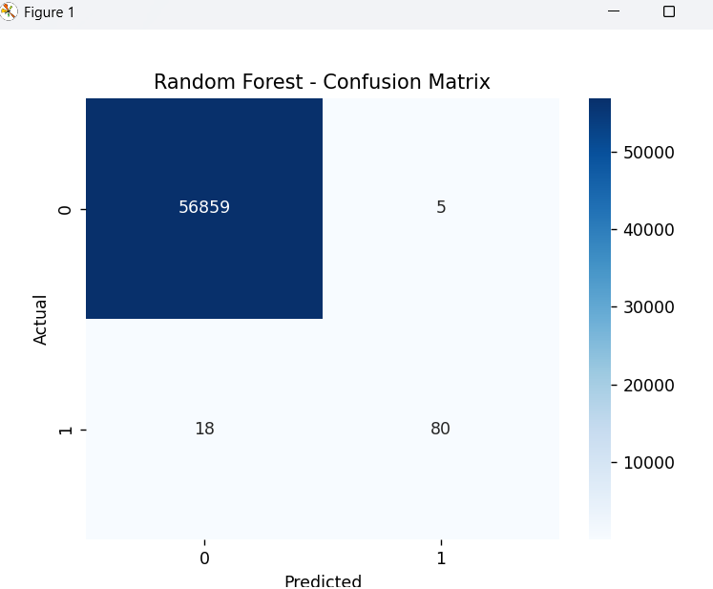

=== **XGBoost Results** ===

precision recall f1-score support

0 0.9996 0.9998 0.9997 56864

1 0.8667 0.7959 0.8298 98

accuracy 0.9994 56962

macro avg 0.9332 0.8979 0.9148 56962

weighted avg 0.9994 0.9994 0.9994 56962

